缓考申请流程说明
网址：https://www.csu.edu.au/current-students/support-services/help-information/special-consideration

1.
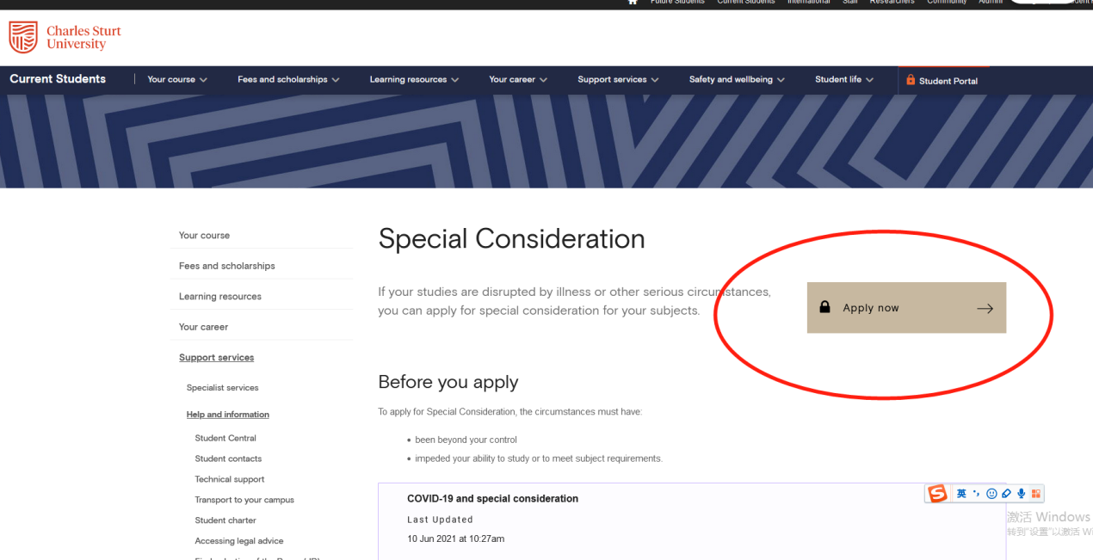

2.
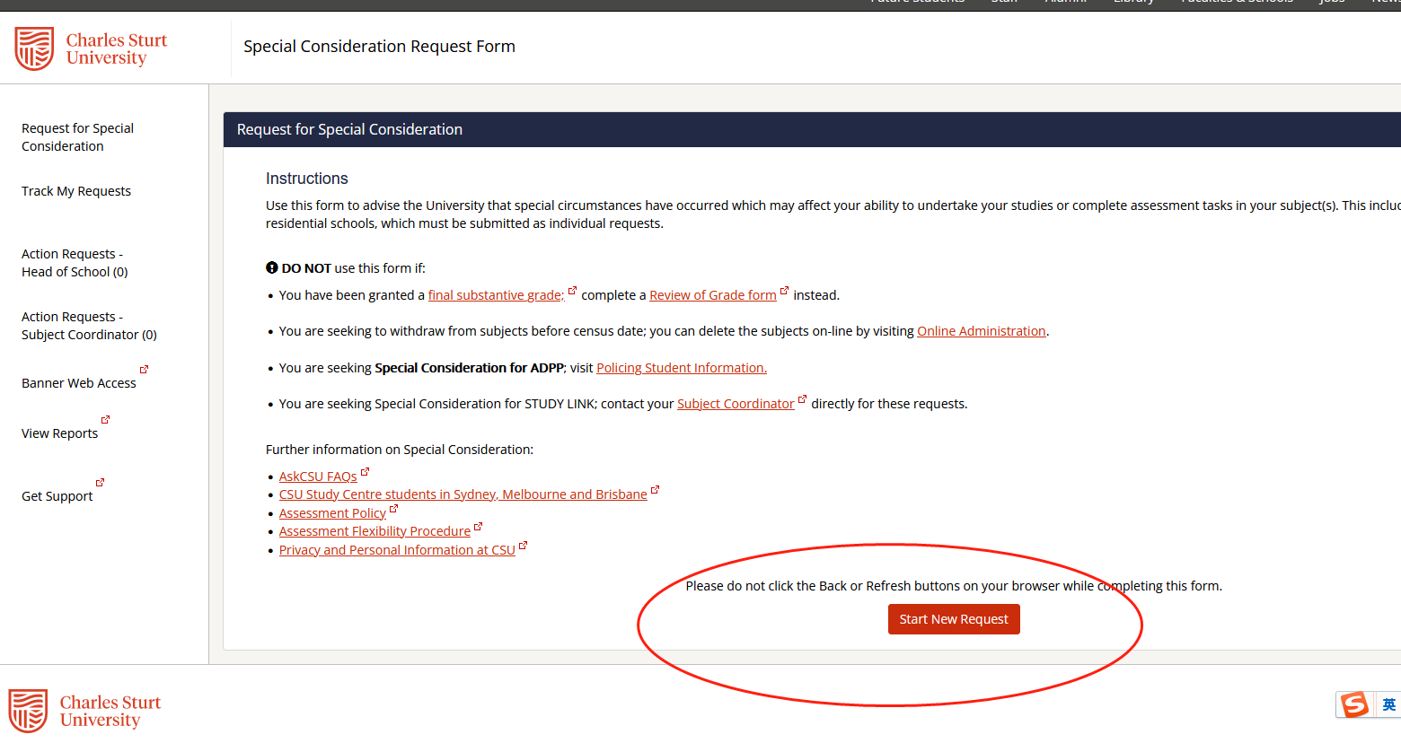

3.选择缓考科目和缓考原因，提交申请
